117th earns AF
meritorious unit
award
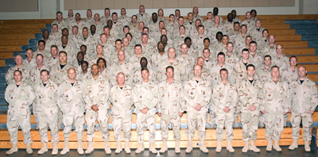
Savannah, GA, May 18, 2007 -- Ninety-eight members of the Savannah-based 117th Air Control Squadron of the Georgia Air National Guard have received the Air Force Meritorious Unit Award as a result of superior performance during Operation Iraqi Freedom from January through May 2006.
The Meritorious Unit Award is among the highest unit awards presented to Air Force active duty, Air Force Reserve, and Air National Guard units. It recognizes exceptionally meritorious service in direct support of combat operations against an armed enemy of the US.
According to Lt. Col. Joe Ferrero, 117th Commander, "The men and women of the 117th will wear this award with pride. While in theater we controlled over 20,000 combat missions, including 350 close air support missions providing air cover for soldiers and Marines under fire. And we did all of this while being subjected to daily mortar and rocket fire. Our people are simply outstanding."
Members of the 117th were part of 332d Expeditionary Air Wing (EAW) as a subordinate unit, of the 727 Expeditionary Air Control Squadron (EACS). The award was authorized by the U.S. Central Command at McDill, AFB.
While deployed to Iraq, the 117th had sole airspace control of the more than 270,000 square miles of Iraqi airspace.
According to Air Force officials, the level of achievement required by the unit to receive the Air Force Meritorious Service Award is the same as that which would warrant the individual award of the Legion of Merit, the highest individual award for non-combat related performance of duty.

