601st Tactical Control Squadron

Status: Inactive Component: Regular Air Force

LINEAGE:
- Established and activated as the 601st Tactical Control Squadron on 31 December 1945.
Note: the 601st TCS was created out of the 555th Signal Aircraft Warning Battalion. This “Triple Nickel” unit was formed in 1942 from a group of specialists who worked at the New England Telephone and Telegraph Company. The 555th earned “five battle streamers:” Normandy (6 Jun – 2 Jul 1944), Northern France (25 Jul – 14 Sep 1944), Rhineland (15 Sep 1944 – 21 Mar 1945), Ardennes-Alsace (16 Dec 1944 – 25 Jan 1945), and Central Europe (22 Mar – 11 may 1945). On 31 Dec 1945, the four companies of the 555th became the 601 TCS, 602 TCS, 603 TCS and 604 TCS. Later the 602 TCS, 603 TCS and 604 TCS would be inactivated. In 1989, I asked the Air Force heraldry office if the “battle streamers” of the 555th could be claimed by the 601 TCS, 602 TCS or 603 TCS. They informed me that no TCS unit created from the 555th could claim the “battle streamers.”
- Redesignated: as the 601st Aircraft Control and Warning Squadron on 1 December 1948.
- Redesignated: as the 601st Tactical Control Squadron on 18 November 1960.
- Redesignated as the 601st Air Control Squadron on 31 March 1992.
- Inactivated: 31 March 1995.

DECORATIONS: Three Air Force Outstanding Unit Awards:
1 April 1959 – 30 January 1961
1 May 1981 – 30 April 1983 (as part of the 601st Tactical Control Wing)
1 January 1988 – 31 May 1990 (as part of the 601st Tactical Control Wing)

ASSIGNMENTS: Dates reflect date unit assigned to Higher Headquarters.
- 507th Tactical Control Group, 31 Dec 1945 (attached to the 51st Troop Carrier Wing [known as European Air Transport Service, Provisional] 25 Jul – 25 Sep 1947)
- 51st Troop Carrier Wing, 25 Sep 1947
- United States Air Forces in Europe, 20 Dec 1947
- 7400th Air Force Communications Wing, 1 Jul 1948 (attached to USAFE, 1 Jul – 21 Dec 1948)
- 7402nd Aircraft Control and Warning Group, 21 Dec 1948
- United States Air Forces in Europe, 7 Feb 1949 (attached to the 7402nd AC&W Group until 10 Jun 1949)
- 501st Aircraft Control and Warning Group, 10 Jun 1949 (501st later redesignated a Tactical Control Group)
- 501st Tactical Control Wing, Provisional, 1 Jul 1955
- 501st Tactical Control Wing, 18 Nov 1957
- 86th Air Division (Defense), 18 Nov 1960
- 38th Tactical Missile Wing, 15 Apr 1961
- 17th Air Force, 15 Jun 1961
- 86th Air Division (Defense), 10 Jun 1964
- 601st Tactical Control Group, 15 Feb 1965
- 601st Tactical Control Wing, 1 Jul 1968
- 601st Tactical Control Group, 1 Jul 1973
- 601st Tactical Control Wing, 1 Jun 1985

COMPONENTS:
- 611th Tactical Control Flight (1970 Call Sign: “Mutate”): 1 Jul 1973 – 1 Oct 1973, unit was located at Alzey AS, Germany. In 1973, the unit became a component of the 603rd Tactical Control Squadron until 1986). The unit in 1986 was again under the 601st Tactical Control Squadron at Alzey AS, Germany until its inactivation on 1 Jul 1991.
- 612th Tactical Control Flight (1970 Call Sign: “Jeremiah”): 1973 – 1991. In 1973, the unit was located at Sembach AB, Germany. In 1973, the unit relocated to Weisbaden AB, Germany. In 1975, the unit relocated to Pruem AS, Germany. In 1989, the unit relocated to Zweibrucken AB, Germany. Unit inactivated in 1991.
- 621st Tactical Control Flight (1970 Call Sign: “Believe”): 1 Oct 1973 – 30 Sep 1986. Unit was located at Weisbaden AB, Germany. Unit inactivated on 30 Sep 1986.
- 622nd Tactical Control Flight (1970 Call Sign: “Calorie”):1986 – 1991. Unit was located at Rhein Grafenstein, Germany. Unit inactivated in 1991
- 631st Tactical Control Flight (1970 Call Sign: “Chalet”): 1 Jun 1985 – 1991. Unit was located at Wurzburg, Germany. Unit inactivated in 1991.
- Det 1, (Forward Air Control Post [FACP]): 1965 – 1973. In 1965, unit was located at Kirchgoens, Germany. In 1968, unit was located at Butzbach, Germany. In 1969, unit was redesignated Det 21. In 1973, unit was redesignated the 621st Tactical Control Flight under the 601st Tactical Control Squadron.
- Det 2 (Control and Reporting Post [CRP]): 1965 – 1973. In 1968, unit was located at Neu Ulm, Germany. In 1968, unit was redesignated Det 22. In 1973, unit was redesignated as the 602nd Tactical Control Squadron (1970 Call Sign: “Biform”) under the 601st Tactical Control Group). Unit was inactivated in 1985.
- Det 3 (FACP): 1965 – 1973. In 1965, unit was located at Fulda, Germany. In 1968, unit relocated to Sembach AB, Germany. In 1969, unit was redesignated as Det 23. In 1970, unit relocated to Alzey Air Station, Germany). In 1973, unit was redesignated as the 611th Tactical Control Flight under the 603rd Tactical Control Squadron.
- Det 4 (FACP): 1965 – 1973. In 1965, unit was located at Wuerzburg, Germany. In 1969, unit was redesignated Det 24. In 1973, unit was redesignated as the 631st Tactical Control Flight under the 602nd Tactical Control Squadron.
- Det 5 (FACP): 1965 – 1973. In 1965, unit was located at Bamberg, Germany. In 1968, unit relocated to Rhein Grafenstein, Germany. In 1969, unit was redesignated Det 25. In 1973, unit was redesignated as the 622nd Tactical Control Flight under the 603rd Tactical Control Squadron.
- Det 6 (FACP): 1965 – 1973. In 1965, unit was located at Grafenwohr, Germany. In 1969, unit was redesignated Det 26. In 1973, unit was redesignated as the 632nd Tactical Control Flight (1970 Call Sign: “Console”) under the 602nd Tactical Control Squadron) Unit was inactivated in 1986.
- Det 7 (FACP): 1965 – 1973. In 1965, unit was located at Straubing, Germany. In 1969, unit was redesignated Det 27. In 1970, unit was relocated to Sembach AB, Germany. In 1973, unit was redesignated as the 612th Tactical Control Flight under the 601st Tactical Control Squadron.
- Det 100 (CRP): 1965 – 1973. In 1965, unit was located at Celle, Germany. In 1968, unit was redesignated Det 8 located at Fischbach, Germany. In 1969, unit was redesignated Det 28 located at Fischbach, Germany. In 1972, unit relocated to Gruenstadt, Germany. In 1973, the unit was redesignated as the 603rd Tactical Control Squadron (1970 Call Sign: “Maroon”). Unit was inactivated in 1986.
- Det 300 (CRP): 1965 – 1973. In 1965, unit was located at Neu Ulm, Germany. In 1968, the unit was redesignated as Det 2 (see above).

STATION. Note: The locations detailed below are only for the main element of the 601st Tactical Control Squadron.
- Simmershausen, Germany 31 Dec 1945
- Hassel, Germany 28 Oct 1946
- Rothwesten AB, Germany 24 Jul 1947
- Pforzheim, Germany 31 Jul 1955
- Sembach AB, Germany 18 Mar 1963
- Weisbaden AB, Germany c. 1 Jun 1973
- Pruem AS, Germany 15 Oct 1975
- Zweibrucken AB, Germany 15 Jun 1989
- Alzey AS, Germany 31 Aug 1991,

COMMANDERS.
- 1 Lt Douglas Eustace 31 Dec 1945
- 2Lt/1Lt Gaylord F. St Thomas 20 Jan 1946
- 1Lt John B. Patterson 02 Mar 1946
- Capt Own A. Knorr c. 08 Apr 1946
- Maj William R. Crooks c. 24 May 1946
- Maj Richard G. Hall 17 Jul 1946
- Maj Lynn A. Breece c. 01 Aug 1947
- Maj Fred K. Durni c. 16 Dec 1948
- Maj Younger A. Pitts Jr. 01 Sep 1949
- Maj/LTC Marshall C. Brown c. Nov 1950
- LTC Daniel Wolf 12 Sep 1953
- Maj Robert J. Murphy c. 10 Apr 1955
- Capt Blaine W. Sweitzer 01 Jul 1955
- Capt Louis L. Klose 28 Aug 1955
- Maj Donald A. Whitcomb 17 May 1956
- LTC John H. Walker c. 20 Jul 1956
- Maj Ronald L. Wolfe 17 Jun 1955
- Maj John Thomson 01 Jul 1959
- LTC Wendell M. Raschke 15 Jul 1959
- LTC James M. Wyse 05 Feb 1963
- Col Emanuel A. Pelaez 15 May 1964
- Maj Bertram W. Wilson 15 Feb 1965
- LTC Harold W. Sohrweide 12 Jul 1965
- LTC Bruce K. Kirkpatrick 12 Jul 1966
- Maj Angus D. McIntyre Jr. 30 Jan 1967
- LTC Kenneth L. Gordon 28 Aug 1967
- LTC James H. Moon 30 Oct 1967
- LTC Ray A. Skidmore 11 Aug 1970
- LTC Leonard R. Peterson 10 Aug 1972
- None – not manned 24 Aug 1972
- LTC Leslie W. White 28 Oct 1972
- LTC Bobby D. Wagnon 06 May 1974
- Maj James L. Johnson 27 Jun 1975
- LTC David E. King 27 Sep 1976
- Maj/LTC Alexander W. Shearer 09 Mar 1978
- LTC Robert E. Pontius 12 Dec 1980
- Maj Richard G. Hoemme 01 Feb 1982
- LTC Jon C. Campbell 25 Jul 1983
- LTC Roy D. Brinkman 21 Jun 1985
- LTC Dan H. Thompson 29 Jan 1987
- LTC Patrick J. Madden 06 Apr 1987
- LTC Daniel Kienker 23 Jul 1990
- LTC John Horan c. Aug 1992

OPERATIONS.
Originally the 601 TCS and it’s detachments provided an early warning radar and direction-finding network to support tactical operations of USAFE and to provide navigational aids to friendly aircraft. The unit helped guide air transports along air routes to Berlin during the 1948 – 1949 Berlin Airlift.
On 31 July 1955, the unit began performing installation and maintenance functions for C-E (communications-electronics) systems and facilities.
On 20 July 1956, the unit resumed its early warning radar role.
From 15 April 1961 until 15 June 1962, the unit operated electronic target director posts in support of a tactical missile mission.
From 15 June 1962 until 31 March 1995, the unit was part of the USAFE Tactical Air Control System (TACS).

EMBLEMS.
The unit has had three different emblems over the course of its history.
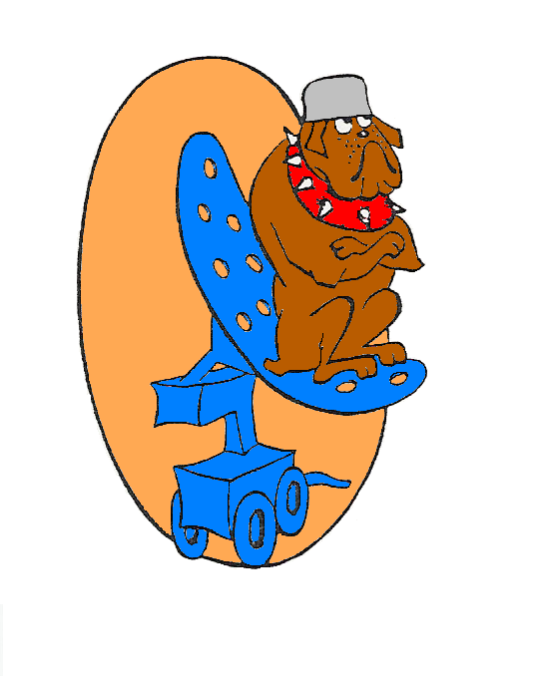
- The original emblem was approved on 19 August 1955 for the 601st Aircraft Control and Warning Squadron and is described as follows: “The caricatured bulldog seated on the antenna of a search radar set, signifies the readiness and watchfulness of the squadron in their mission. Description: Over a light tan oval shape, a caricatured brown bulldog, wearing a around his neck a red spike collar, and on his head a gray helmet; the dog seated on the antenna of a search radar set of blue, all outlines and detail in black.”
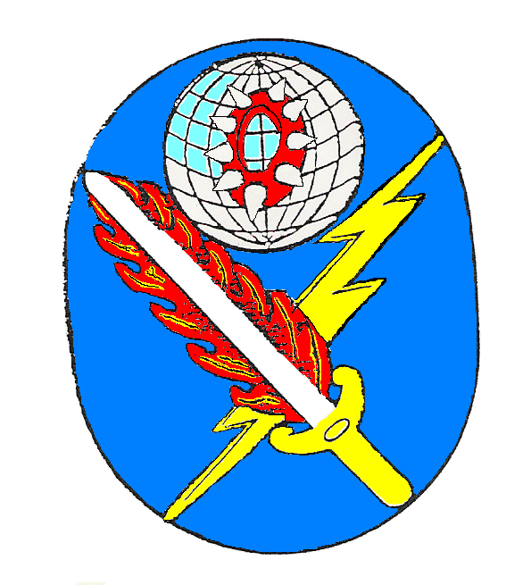
- The second unit emblem was approved on 13 April 1964 for the 601st Tactical Control Squadron and is described as follows: “The emblem is symbolic of the squadron, its history and present mission. The red spiked collar refers to the unit’s history, representative of the Iron Curtain which divided Western and Eastern Germany when the squadron was activated in Germany, 31 Dec 1945, and signified the squadron’s readiness and watchfulness. The flaming sword represents USAFE and the lightening flash, communications and guidance capabilities. Together these two symbols denote the squadron’s control within the USAFE complex. The globe alludes to the units world wide mission capabilities. The emblem bears the Air Force colors ultramarine blue and golden yellow.
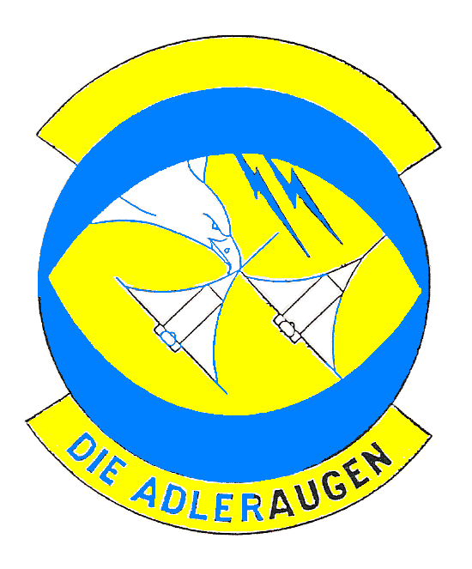
- The third unit emblem was approved on 23 Jan 1979 for the 601st Tactical Control Squadron and is described as follows: “Bolts of radiation symbolize electromagnetic radiation/radar of Ground Control Intercept (GCI). They also symbolize communication and control of aircraft. Aircraft: diagrammatic sketch of two jet fighters, the primary weapons system of the Air Force which our squadron supports and controls during airborne operations. The two aircraft are swooping out of the sun, as if rolling in on a target’s six o’clock as a result of GCI control. Eagle: Symbol of power, clear eyesight, ruler and predator of the skies, and of the United States of America. The outline of the patch describes an eye, the golden yellow of the eye is also the center and it represents the sun.”

MILESTONES.
Note: Information for this section taken from Air Force lineage and 601st Tactical Control Wing historical files.

