Birth of the Aircraft Control and Warning Group in the Pacific Theater in WW II

The following is typed verbatim from the 86th Fighter Wing’s History report for May 1945.This report was found in the Air Force Historical Research Agency’s microfilm C0041 s/ Gene C. Smith, Pasadena, CA 2008

Background: There were two Fighter Wings in Southwest Pacific: 85th and 86th Fighter Wings and they shared three Detachment Fighter Wing (Separate), Detachment “G”, “H” and “I”. Detachment “G” and “I” will stay with the 86th to form their AC&W Groups. Completing the team are the Signal Aircraft Warning Battalions that provide the equipment, installation, operators and maintenance personnel; and the Fighter Control Squadrons provide provided the controllers.

The Assault Units of the Detachment were brave men going from island to island aboard LSTs. On D-Day and only hours after assault troops landed they would go ashore with their trucks of equipment and personnel to set up the initial air defense of Light Weight radars. The remainder of the Detachment would arrive after D-Day with the remainder of the equipment to set up the permanent Control Centers with additional Mobile and Light Weight radars. Training complete and operations running the Detachment would head out to put together another team for their next assignment.

By May 1945 the Philippines was reoccupied and Air Defense was turned over to the Philippine Army. It was time to get ready for the final big assault on the mainland of Japan. It was decided the island type operation was not suited for the invasion of Japan and the Air Forces would reorganize using the model used in Europe, a Tactical Air Force.

And here is how it happened

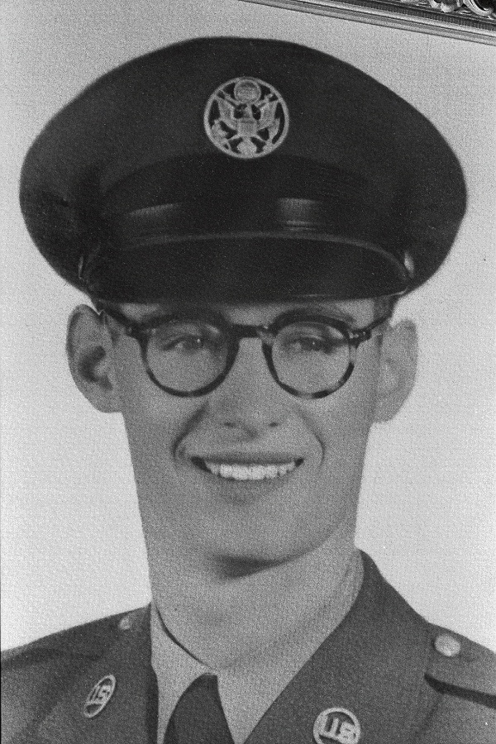

Gene C. Smith

Pasadena, CA

2008

1953 Keesler AFB, MS

Designation Sheet
Air Force: Fifth Air Force
Command: V Fighter Command
Wing : 86th Fighter Wing
Period : May 1945

HEADQUARTERS 86TH FIGHTER WINF
APO 70
27 Jul 1945
SECRET
Auth: CG VFC
Subject: Transmittal of Unit History
To: Commanding General
Army Air Force
Washington 25, D.C.

- In accordance with AR 345-108 and AAF Regulation No. 20-8 submit
herewith Chapter 18 (May, 1945) of the history of this organization, which
has been inspected and verified by the undersigned.
- The material submitted was prepared by Lt. Col. Bernard R.
O’Connor, 0338301, AC, and T/Sgt. Robert S. Reed, 39291141, AC. Facts
and observations in the narrative not otherwise credited are based on the
personnel knowledge and opinions of Lt. Colonel O’Connor and T/Sgt. Reed
- The following materials are included.
  - Narrative for May 1945
  - Two Document enclosures

s/Robert L. Johnston
Robert L. Johnston
Colonel, Air Corps
Commanding

Narrative History
Headquarters 86th Fighter Wing
May
1945
For the 86th Fighter Wing, the month of May 1945 began as if it were to be another 31 days of accomplishing, the by then routine mission of providing and operating adequate air defense and fighter control facilities for the island of Luzon, in the Philippines. But before the month was out, Germany had surrendered unconditionally, Wing personnel had been agitated into minor uproar by the announcement of the War Department’s Redeployment and Readjustment Plan, and the Wing had been given an additional mission, the accomplishment of which would foreshadow the inactivation of the Wing as a unit of the Air Force.
The announcement of Germany’s surrender on May 8 was taken in stride by Wing personnel. There was still a full scale war going on in the Pacific. What did bring cheer was the realization that the full strength of the United Nations could at least be employed against Japan, hastening the day of final victory.
Excitement ran high when, on May 12, orders were received from Fifth Fighter Command that records of both enlisted men and officers of the Wing and all subordinate units would be brought up to date and kept current in respect to the number of months overseas, the number of months served in the Army, the number of bronze stars and decorations, and the number of children. This was the first inkling that the long discussed “point system” for discharge eligibility was being put into effect.
On May 15 the men of Headquarters and Headquarters Squadron were assembled and First Lieutenant Tex Chudnovsky, Headquarters Squadron Adjutant, explained the Redeployment and Readjustment Plan. Each man was to be given one point for every month served in the army since September 16, 1940. An additional point to be given for each month served overseas. Each decoration and bronze service star was to add five points. Each child under 18 years of age, up to three, was to be worth 12 points. A temporary score for eligibility for discharge had been set at 85, a permanent critical score to be announced by the War Department within 60 days.
The motion picture demonstrated the working of the “point system” prepared in advance by the War Department, was shown for the benefit of officers and men on May 19. This film made it definite that members of the Army Air Force, whether or not they qualified as eligible for discharge, would be released only if they were not needed in the war against Japan – and that most of them would be needed.
The day following the showing of the film the Headquarters Squadron orderly room personnel had completed special individual Redeployment and Readjustment Forms for each man. These forms showed each man’s score in points. The average score for enlisted men was approximately 60. The average score for officers was somewhat higher, since most officers had been in service longer than the average enlisted man.
While the Redeployment and Readjustment Plan was thus being put into effect, Colonel James O Guthrie, Wing Commander, and Colonel Robert L. Johnston, Wing Chief of Staff, were attending a lengthy series of conferences at Fifth Air Force and Fifth Fighter Command Headquarters. These conferences concerned a proposed reorganization of the Air Force in the Pacific Theater to assure efficient operation in the stepped up future air operation against Japan. The outcome was a proposed streamlining that would dispense with Fighter Commands and Fighter Wings create Tactical Air Forces, Tactical Air Command and Aircraft Control and Warning Groups, thus making possible a better coordination for joint operations of the Air and Ground Forces. It was agreed as these conferences came to an end that the proposed reorganization would be presented for discussion and recommendations for change to the ranking officers of the units that would be affected. Colonel Johnston was given the task of explaining the tentative Table of Organization of Headquarters and Headquarters Squadron of such a unit for discussion and comment.
Within a few days, another conference was called at Fifth Fighter Command Headquarters. Assembled were the Chief of Staff, Operations Officer and Communications Officer of Fifth Air Force; The Commanding General, Operations Officer, and Signal Officer of Fifth Fighter Command; the Commanding General, Operations Officer, and Signal Officer of the 308th Bombardment Wing; the Commanding Officer, Operations Officer, and Signal Officer of the 309th and 310th Bombardment Wings, and Colonel Guthrie and Colonel Johnston.
Addressing the assembled officers, Colonel Johnston first pointed out that the birth of the tactical Air Force and Tactical Air Command was fostered by necessity in the European Theater, since, prior to the advent of land warfare in Europe, it was realized that the current unwieldy organization of the Army Air Forces in Europe was not adaptable to the necessary joint operations necessary in the fluid stages of land warfare. A study of the problem was made, and a tentative organization was set up and operated under simulated conditions at Orlando, Florida. The class room solution to the problem of gaining closer coordination between air and ground forces in combat thus obtained was immediately applied in the European Theater, and smoothly operating Tactical Air Forces and Tactical Air Commands were successfully and efficiently employed against Germany.
Colonel Johnston said that a review of the organization of the Air Forces in the Pacific Theater had revealed that its ability to efficiently operate available and redeployed air power in future stepped-up operation against Japan could be improved, and that it was believed that the improvement could be best attained by reorganization into Tactical Air Forces and Tactical Air Commands.
A Tactical Air Command, Colonel revealed, is an Air Task Force having a threefold mission – to gain and maintain air superiority, to isolate the Battlefield, and to participate in the coordinated effort of the air and ground forces in the battle area to gain objectives on the immediate front of the ground forces.
To accomplish this mission, the Tactical Air Commander through clear cut and streamlined command channels controls operationally and administratively assigned fighter groups, bomber units, reconnaissance units, necessary air strips, service units and Aircraft Control and Warning Groups.
An Aircraft Control and Warning Group ia a streamlined organization capable of providing air warning, offensive and defensive control of fighter and bomber aviation, and control of antiaircraft artillery in the communication zone. The group consists of a Group Headquarters, two Aircraft Control Squadrons (Mobile and Light Weight), an Aircraft Control and Warning Squadron (Heavy), two Aircraft Warning Squadrons (Mobile and Light Weight), and a Tactical Control Squadron. A Radar Calibration Detachment is attached to the Group.
With the exception of actual air combat, the primary mission of a Tactical Air Command – to obtain and maintain air supremacy in its zone of operation – is principally accomplished by the facilities of the Aircraft Control and Warning Group. With radio direction finding, ground control interception and other types of radar equipment essential for the detection of enemy aircraft and control of our own, the Group is capable of accomplishing the establishment for the gaining of air supremacy.
In the isolation of the battlefield, the second phase mission of a Tactical Air Command, the part played by the Group is mainly that of controlling and aiding our own aircraft in starting to and returning from their mission – most targets being in rear areas beyond the range of radar equipment. If possible, however, aircraft are controlled to targets.
The Aircraft Control and Warning Group plays the major role in the accomplishment of the third phase mission of the Tactical Air Command – that of participating in the combined effort of the air and ground forces in the battle to gain objectives on the immediate front of the ground forces. In execution of this mission the Group plays a leading position in a system designed to adequately give air support to ground troops at the specific time and place necessary to bring about the greatest destruction of enemy ground forces opposing the advance of our own troops. At the same time the Group retain such flexibility as to revert momentarily to the accomplishment of the primary and first phase mission.
Of the functions of the Aircraft Control and Warning Group, the only one new to the Pacific Theater was that of controlling air support missions. To adequately control such missions the Group is divided tactically into three elements: The Tactical Control Center, The Forward Director Post and the Tactical Control Post.
The Tactical Control Center is physically located in close proximity to the headquarters of the Tactical Air Command, being the nerve center of the command. All information utilized in accomplishing support missions is received, plotted and evaluated. Ground intelligence is received at the center from the air-ground information center at Army Headquarters, always located with the Tactical Air Command.
The Forward Director Post is normally a radar unit located so as to be capable of tracking plane flights and vectoring the planes to any given position within its area of coverage. When the situation warrants, a Post may also serve as a Ground Control Intercept or Radar Reporting Unit.
The Tactical Control Post is a small unit which controls aircraft to targets in direct support of ground operations, and is normally located in the front area so targets to be attacked can be observed either visually or by radar.
All radar units not utilized in the three elements primarily used to control support missions are dispersed throughout the area to provide complete early warning coverage.
In thus explaining the functions of the Aircraft Control and Warning Group, Colonel Johnston did not intend that his discussion should be construed as a limitation on the employment of the Group, but as a guide for educational purposes.
On May 25 [1945], Fifth Fighter Command informed the Wing that three Aircraft Control and Warning Groups were to be immediately organized and trained, these groups to be formed from troops assigned to the Command. Further, the 86th Fighter Wing was to be responsible for reorganizing, retraining and re-equipping these units.
Pending War Department authorization for the Group, already requested by Fifth Fighter Command, the reorganization was to go forward on a provisional basis. Units to make up the groups were to be relieved from operational assignment and moved to training areas. There was to be no change in the designation of units involved in the reorganization until the War Department authorized the activation of the groups.
Units to be utilized for the reorganization were as follows:
Headquarters Wing Detachment “G”
Headquarters Wing Detachment “I”
596th Signal Aircraft Warning Battalion
565th Signal Aircraft Warning Battalion
583rd Signal Aircraft Warning Battalion
349th Signal Company Wing
35th Fighter Control Squadron
33rd Fighter Control Squadron
56th Fighter Control Squadron
In addition, Headquarters and Headquarters Squadron, 86th Fighter Wing, was to be utilized in forming the third group, the Wing having first organized and trained the first two.
The first group was to be organized and trained prior to July [1945] at Lingayen [Luzon, P.I.], with its target date being September 1. The second was to be formed at Manila [Luzon, P.I.] prior to August 1, target date being October 1. Prior to September 1 [1945] at Lingayen, the third group was to be organized and trained, its target data being November 1, [1945].
Since Colonel Guthrie was scheduled to be transferred to the Thirteenth Fighter Command as Chief of Staff within a short time, Colonel Johnston was given the task of planning and accomplishing the organization, training and equipping of the new groups. He immediately scheduled conferences with the necessary staff officers of the Wing and officers of units involved in the reorganization.
Wing Operations in regard to the accomplishment of their primary mission, the maintaining and operating of adequate air defense and fighter control facilities for Luzon Island [P.I.], were strictly routine during May [1945].
All subordinate units were relieved from administrative plans. However, the Wing remained in operational control of the 547th and 421st Night Fighter Squadrons. P-51s of these squadrons maintained constant patrols over Central and Northern Luzon.
Only one Red Alert was called in the Lingayen area during the month of May. That was on the night of the last day of the month – and it was caused by a friendly B-25 that failed to show its IFF.

In the June 1945 History Report the organizations are defined:

Aircraft Control and Warning is Created

5275th Aircraft Control and Warning Group
Lt. Colonel Franklin L. Douty, Commanding Officer
New Organization | Source of Personnel/Equipment
Group Headquarters | Wing Detachment “I”  Hq. 596th SAW Bn
Control Squadron (Mobile) | 56th Fighter Control Squadron
Control Squadron (Lightweight) | Co. “B”, 586th SAW Bn
Aircraft Control and Warning Squadron | Co “C” 596 SAW Bn
Aircraft Warning Squadron (Mobile) | Co “B” 565th SAW Bn
Aircraft Warning Squadron (Lightweight) | Co “A” 583rd SAW Bn
Tactical Control Squadron | Co “D” 596th SAW Bn

5276th Aircraft Control and Warning Group
Major Samuel R. Spann, Commanding officer
New Organization | Source of Personnel/Equipment
Group Headquarters | Wing Detachment “G”  Hq. 583 SAW Bn
Control Squadron (Mobile) | 33rd Fighter Control Squadron
Control Squadron (Lightweight) | Co “B” 583rd SAW Bn
Aircraft Control and Warning Squadron | Co “C” 583rd SAW Bn
Aircraft Warning Squadron (Mobile) | Co “A” 565th SAW Bn
Aircraft Warning Squadron (Lightweight) | Co “A” 596th SAW Bn
Tactical Control Squadron | Co. “D” 583rd SAW Bn

5277th Aircraft Control and Warning Group
Lt. Col. Tasso W. Schwartz, Commanding Officer
New Organization | Source of Personnel/Equipment
Group Headquarters | Headquarters, 86th Fighter Wing
Control Squadron (Mobile) | 35th Fighter Control Squadron
Control Squadron (Lightweight) | Hq. Sq., 86th Fighter Wing
Aircraft Control and Warning Squadron | Hq., 565th SAW Bn
Aircraft Warning Squadron (Mobile) | Co “C” 565th SAW Bn
Aircraft Warning Squadron (Lightweight) | 349th Signal Company Wing
Tactical Control Squadron | Bn. Hq. Co., 565th SAW Bn

SAW Bn = Signal Aircraft Warning Battalion

