U.S. Air Force
Airman 1st Class Scott Palomino Wounded Airman Receives Purple Heart By U.S. Air Force Staff Sgt. Melanie Streeter
Air Force Print News
WASHINGTON, May 3, 2004 — Air Force Airman 1st Class Scott Palomino, who lost a leg due to an attack in Iraq, received the Purple Heart and an Air Force Commendation Medal from Air Force Chief of Staff Gen. John P. Jumper at Walter Reed Army Medical Center here on April 20.
Palomino is a surveillance technician from the 603rd Air Control Squadron based at Aviano Air Base, Italy. He was wounded April 10 when a mortar round exploded in his tent at Balad Air Base, Iraq. That wound resulted in the amputation of Palomino’s left leg below the knee.
Besides Jumper, Chief Master Sgt. of the Air Force Gerald R. Murray visited Palomino at Walter Reed and thanked him for his service.
Meeting Jumper and Murray is not something most 19-year-old airmen are used to, but Palomino said he is getting used to it.
“At first, it’s a little bit intimidating,” he said. “But then it made me realize, hey, the Air Force is really taking care of me.”
That care may be why Palomino is not ready to leave the Air Force, despite his injury.
“I want to stay in,” he said. “And a lot of people tell me they don’t think it will be a problem.”
Palomino will stay at Walter Reed throughout the healing process. There, he will be fitted for a variety of prosthetics and undergo physical therapy to help him use the devices.
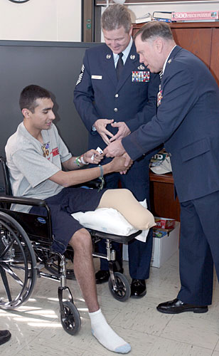
Chief Master Sgt. of the Air Force Gerald R. Murray (center) watches Air Force Chief of Staff Gen. John P. Jumper present his coin to Airman 1st Class Scott Palomino. Jumper also presented the wounded airman with a Purple Heart and an Air Force Commendation Medal at Walter Reed Army Medical Center on April 20. U.S. Air Force photo by Master Sgt. Jim Varhegyi.

