728th deploys to Iraq for fifth time

Families say goodbye as members of Air Control Squadron leave on four-month tour

Mladen Rudman

Thursday January 10th, 2008
EGLIN AFB — Real Daddy is heading to the Middle East for the fourth time, so “flat daddy” will sit in as substitute.
Tech. Sgt. David Smith, a.k.a. Real Daddy, of the 728th Air Control Squadron deployed with some 200 fellow Demons on Thursday.
He and his wife, Renea, and the couple’s three children said their goodbyes well prepared for David’s four-month-long tour.
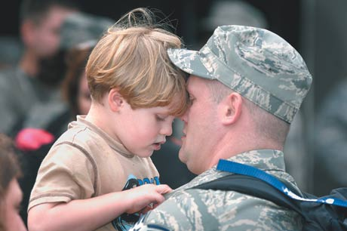
DEVON RAVINE | Daily News
Tech. Sgt. David Smith visits with his son, Garner, on Thursday before he and about 200 other airmen from the 728th Air Control Squadron leave Eglin Air Force Base for the Middle East.
Well prepared isn’t the same as easy, however.
“It’s still hard,” said Smith, a heating and air conditioning specialist. “The fact I’m leaving my wife and kids is the hard part.”
When Smith gets to the Middle East air base — he has been to Iraq three times with the air control squadron — he expects the first few weeks to be hectic.
After that, routine takes over.
“We’ll get into our little groove and work our 12-hour shifts,” he said.
Keeping a connection to Renea and their two young boys and girl is topmost on Smith’s mind. He requested the night shift so he can call home come at about 8 a.m., for example.
Keeping the family connected to her husband is the most important thing to Renea.
“Everyone who has someone deployed worries about them,” she said. “It’s the deployments that make you appreciate everyday life.”
The family’s well-being is in God’s hand, Renea continued. But she’s has a few plans of her own.
The Smiths on the homefront will depend on kin and their family at First Baptist Church of Crestview for support.
And, there’s always “flat daddy,” a life-size picture of David from the waist up. When Renea, Garner, Gregory and Mary Grace sit down to eat, daddy will be in a chair at the table with them.
The Smiths were among many people in high spirits gathered at the Demons compound on Eglin Air Force Base.
Squadron commander Lt. Col. Douglas Hagen noted the unit’s most recent anonymity-preserved “climate assessment” indicated very high morale.
Although he was an E-8 surveillance aircraft mission crew commander before coming to the 728th ACS six months ago, Hagen knows what the Demons do.
Like most aircraft in Iraq’s crowded air space, Hagen’s JSTARS were guided by 728th ACS airmen to ensure there would be no mid-air collisions and that aircraft got where they were going based on priority. The unit operates a ground-based radar that reaches scores of miles up to 100,000 feet.
Hagen also served as a first lieutenant with the squadron.
“I’m now commanding the same unit that I started with, so not everything is unfamiliar,” he said, grinning.
Hagen was upbeat. He had confidence in his airmen and their experience.
Sixty percent of them heading to the Middle East on Thursday had deployed with the unit either the last time it was there or the time before. All together, the 728th ACS has been to the Central Command theater in support of Operation Iraqi Freedom four times since 2003. This is its fifth tour.
“The guys have been preparing for the last three months,” said Hagen. “Everybody (has done) an outstanding job.”
Daily News Staff Writer Mladen Rudman can be reached at 863-1111, Ext. 1443.

