Lockheed shows TPS-79 radar at DSEi
September 8th, 2009 | DSEI 2009 | Posted by Antonie Boessenkool
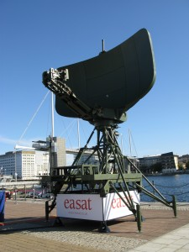
The TPS-79 radar developed by Lockheed Martin and Easat
LONDON – Lockheed Martin displayed its TPS-79 multi-mission surveillance radar system at DSEi, aiming at attracting customers looking for a quickly-deployable radar that can be a gap-filler for unsurveilled air space.
The next-generation medium-range system can be set up in less than 60 minutes and is comparatively light-weight, being made out of carbon composites, Lockheed and Easat representatives said. It can be a ground-based fixed or transportable system.
Lockheed teamed with U.K. radar antenna and systems maker Easat to build the system. Easat designed and builds the radar, while Lockheed provides the electronics, transmitter, receiver and trailer to transport the radar.
The two companies are aiming to compete the system for the United Kingdom’s Joint Military Air Traffic Systems contract, a GBP 2 billion deal to overhaul and run the military’s air traffic control infrastructure. Other competitors could include VT Group, Serco and Thales. Raytheon, BAE Systems, EADS and Selex could also be competitors, said Jim Bunnell of Lockheed at the show.
So far, Columbia has bought three of the systems, and one system is deployed with each of the U.S. Navy and the U.S. Marine Corps, Bunnell said. An African country Burrell wouldn’t name has ordered three, and an unnamed European country has ordered 19 systems, he said. Lockheed and Easat also are eyeing military competitions expected in the next 12 months in Germany and the Netherlands, Burrell said.
The system has a “3-D” capability, Bunnell said, meaning it provides not just range and azimuth information, but elevation information too.
The radar has a range of 100 nautical miles as a surveillance tool and 80 nautical miles as an air traffic control system, Bunnell said.

